MySQL Walmart Sales Analysis
1) Create Database
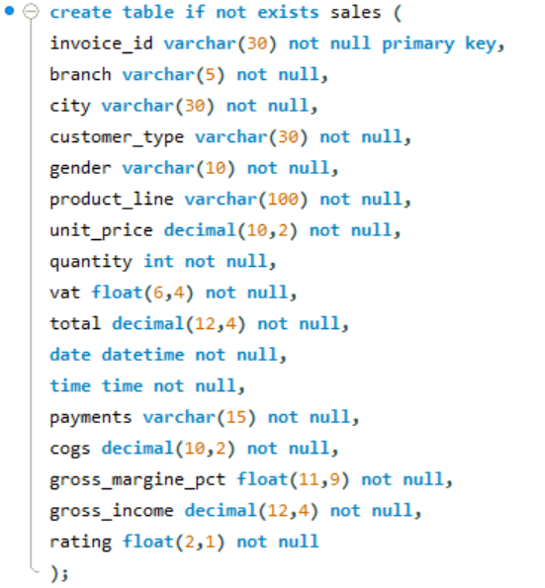
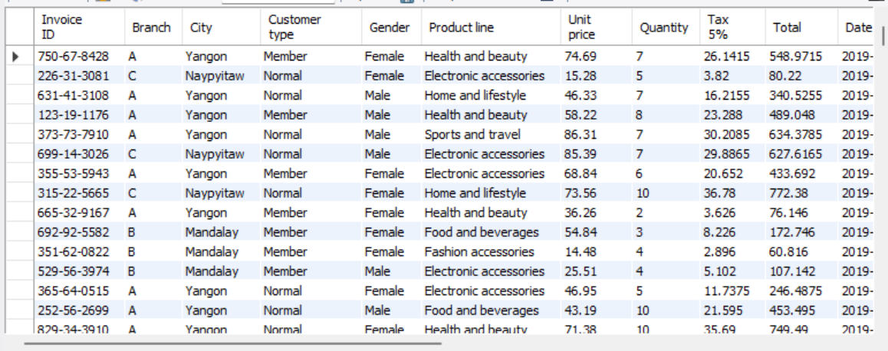
2) Add the Time of day column
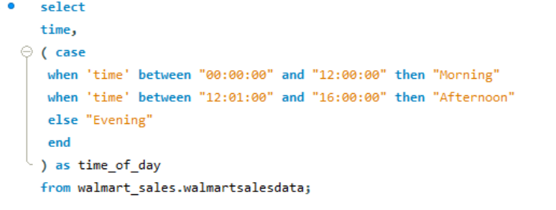
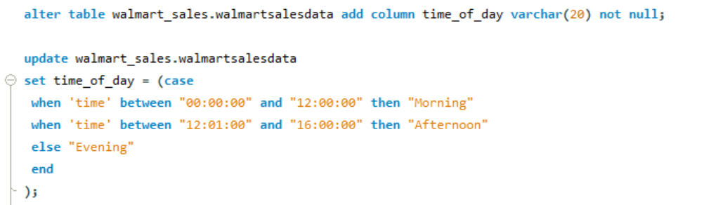
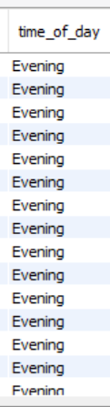
3) Add the Day Name Column
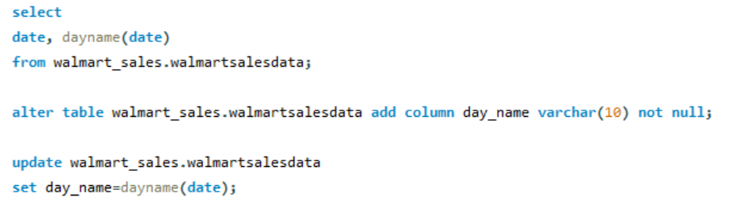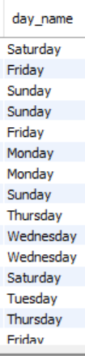
4) Add the Month Name Column
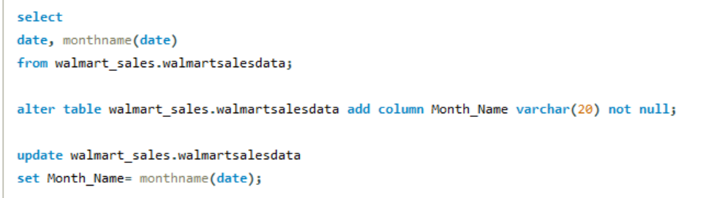
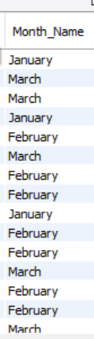
5) Find the Unique cities of the data
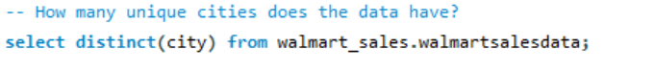
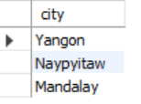
6) Find Distinct cities for each branch
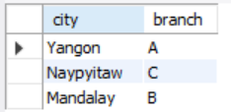
7) Find the most common Payment Method
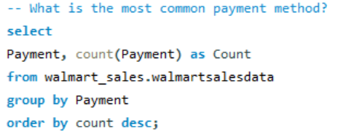
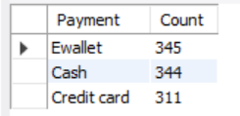
8) Find Month wise Total Revenue
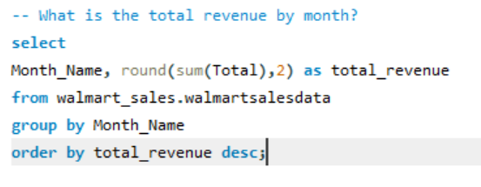
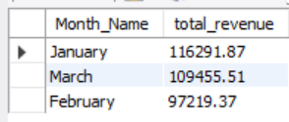
9) Which Month had the largest COGS?
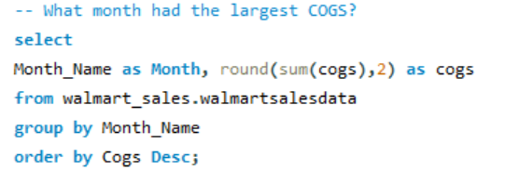
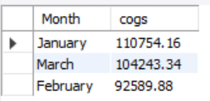
10) Find the City with Largest Revenue
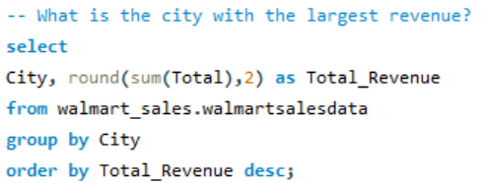
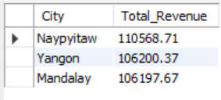
11) Which branch had sold more products than the average product sold?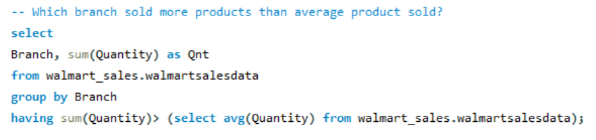
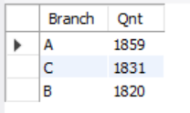
12) Total Sales for each time of the day per weekday
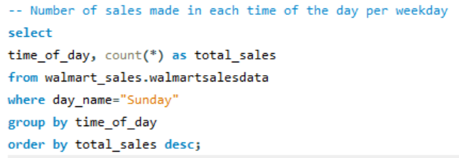
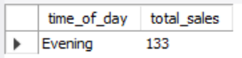
13) Which Customer Types brings the most Revenue?
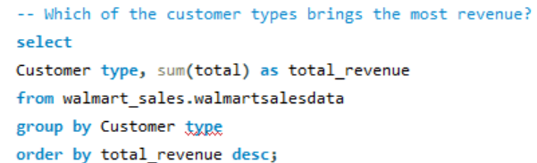
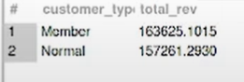
14) Which city has the largest VAT?
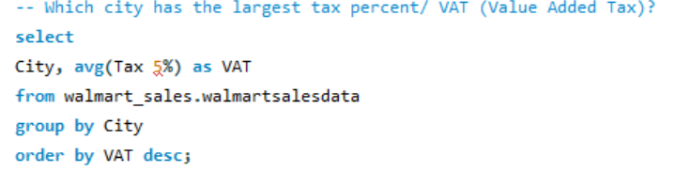
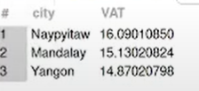
15) Which Customer Type pays the most VAT?
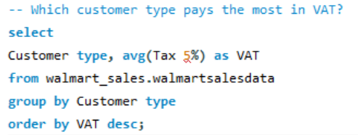
16) Find the Unique Customer Types of the Data.
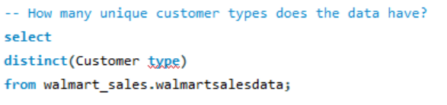
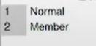
17) Find the Unique Payment Methods of the Data.
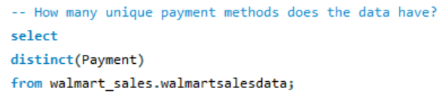
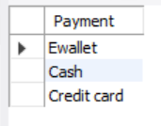
18) Which Customer Type buys the most?
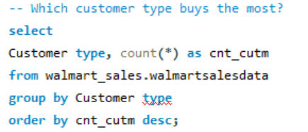
19) What is the gender of the most of the customers?
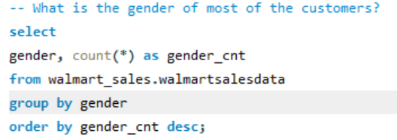
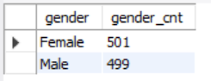
20) what is the gender distribution per branch?
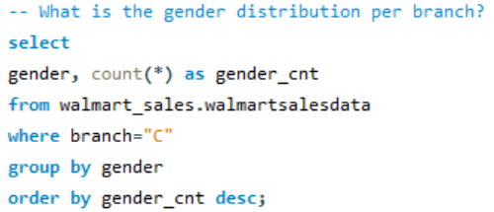
A 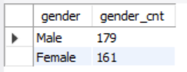
B 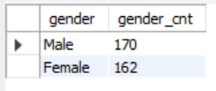
C 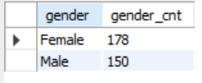
21) Which time of the day do customers give most ratings?
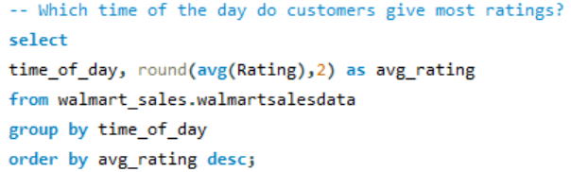
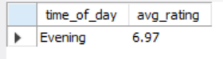
22) Which time of the day do customers give most ratings per branch?
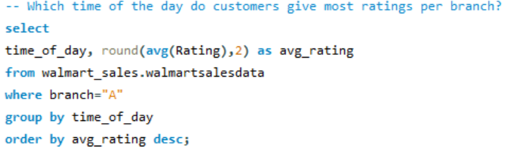
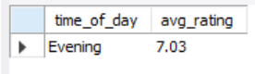
23) Which day of the week has the best avg ratings?
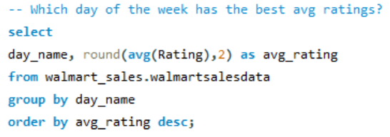
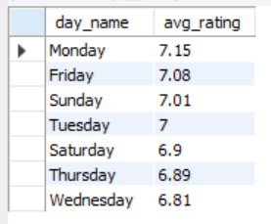
24) Which day of the week has the best average ratings per branch?
